Classes and Objects
_____________________________________________________________________________

Q. What is class?
_____________________________________________________________________
class is combination of state and behavior here state means variable declared within class and behavior means function define within class.

Q. How to declare class in C++?
_________________________________________________________________________________
If we want to declare class in C++ we have following syntax

class classname{
access specifier:
datatype variablename;
datatype variablename;
return type functionname(arguments){

}
};
Example:
class Employee{
private :
int id;
char name[90];
long int sal;
public:
void setData(){
cout<<”\nEnter name id and salary of employee\n”;
cin>>name>>id>>sal;
}
void showData(){
cout<<name<<”\t”<<id<<”\t”<<sal<<”\n”;
}
};

Code description
class Employee: Here class is keyword for class declaration purpose and Employee is class name and user can give any name to his class.

private & public : Here private and public are the access specifier

Q. What is access specifier?
______________________________________________________________________
Access specifier is the some keywords which are used for apply restriction on class and its member.

There are three types of access specifier in C++
_______________________________________________________________________________
private: private are the access specifier and when we declare member as private in class then member cannot access outside of class just member can access within class body
protected: if we declare any member as protected in class then member can access only within child class cannot access outside of child class.
public: if we declare any member as public then member can access outside of class using its object.

If we think about void setData() and showData() these are the functions define within class

Q. Why use class or what is benefit of class?
__________________________________________________________________________________
There are three major benefits of class.

1. Ability to store any type of data
class Employee{
private :
int id;
char name[90];
long int sal;
public:
void setData(){
cout<<”\nEnter name id and salary of employee\n”;
cin>>name>>id>>sal;
}
void showData(){
cout<<name<<”\t”<<id<<”\t”<<sal<<”\n”;
}
};
Note: if we think about above code we have class name as Employee which contain three types of data i.e id is type of integer, name is type of string and sal is type of long int means it contain different type of data.

2. Code Reusability
_________________________________________________________________________
Code reusability means we can declare class only once and we can reuse it more than one time

How we can reuse class more than one time?
_____________________________________________________________________________
If we want to reuse class more than one time then we required to create its object.

What is object?
________________________________________________________________________
Object is block of memory where class data store or object is instance of the class or object is run time entity.

How to create object of class using C++
_________________________________________________________________________________
If we want to create object of class in C++ we have following syntax.

Syntax: classname objectname;
Example: Employee emp;

Here emp is object of Employee class means emp contain all data or variable which is present in Employee class shown in following diagram.

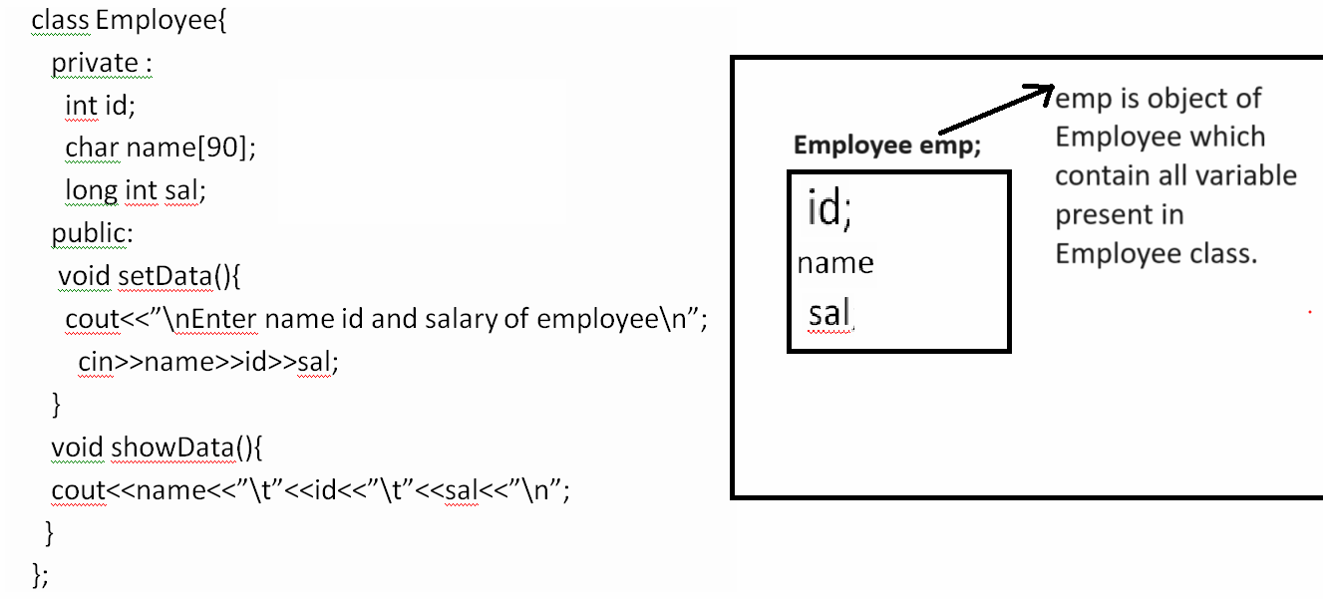
Note: once we create object of any class using that object we can access public member of class using
object.membername;

Steps to use any class in C++
_____________________________________________________________________
1. Declare class
_______________________________________________________________
class Add{
private:
int a,b;
public:

};

2. Define function within class
class Add{
private:
int a,b;
public:
void setData(){
cout<<”Enter two values”;
cin>>a>>b;
}
void showAdd(){
cout<<”\nAddition is “<<a+b<<”\n”;
}
};

3. Create object of class
void main()
{ Add ad; //create object of class

getch();
}

4. Call its public member using object.membername

void main()
{ Add ad; //create object of class
ad.setData();
ad.showData();
getch();
}

Following example shows the working of above code.
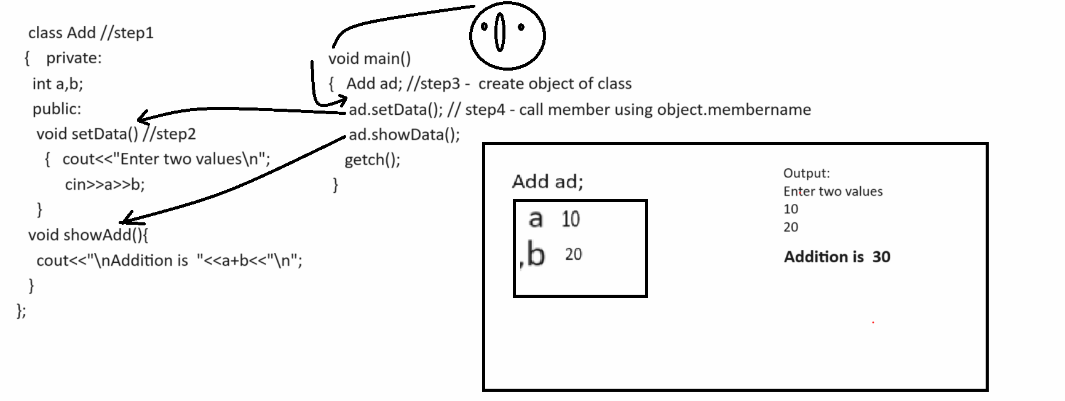

Example with source code.
#include<iostream.h>
#include<conio.h>
class Add //step1
{ private:
int a,b;
public:
void setData()//step2
{ cout<<"\nenter two values\n";
cin>>a>>b;
}
void showData()
{ cout<<"\nAddition is "<<a+b<<"\n";
}
};
void main(){
clrscr();
Add ad;
ad.setData();
ad.showData();
getch();
}

Example: WAP to create class name as Table with two functions
void setValue(): this function accept number from keyboard
void showTable(): this function can print the table of number.
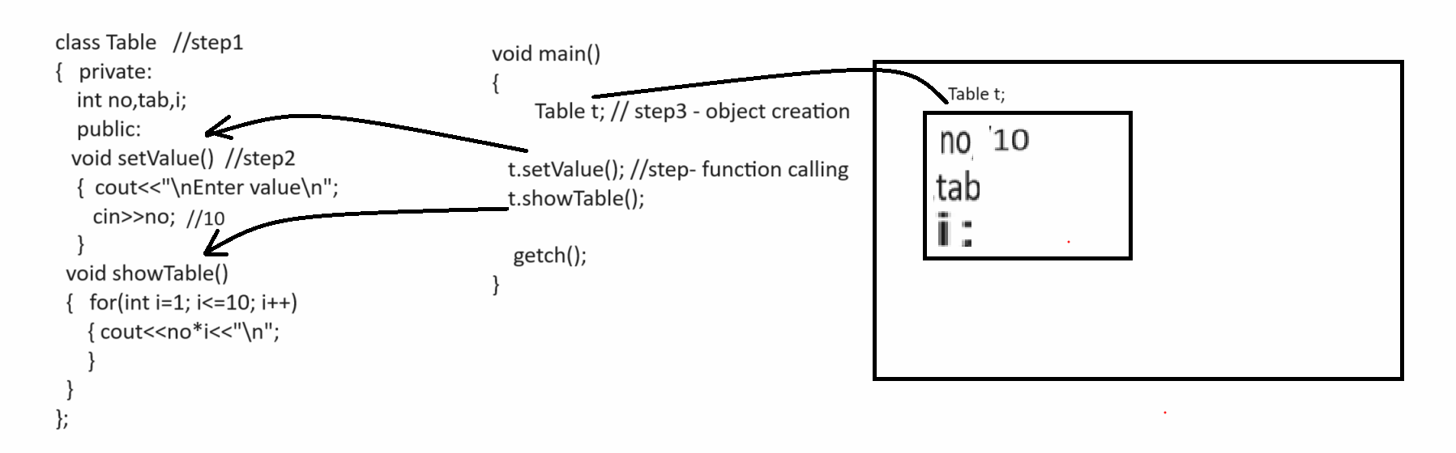

#include<iostream.h>
#include<conio.h>
class Table
{
private:
int no,i,tab;
public:
void setValue(){
cout<<"\nEnter number\n";
cin>>no;
}
void showTable()
{ for(i=1;i<=10;i++)
{ cout<<no*i<<"\n";
}
}
};
void main(){
clrscr();
Table t;
t.setValue();
t.showTable();
getch();
}

Example: WAP to create class name as Power with two functions
void setValue() : this function accept two values first as base and second as index
int getPower(): this function calculate power of number and return it.

Example: WAP to create class name as Factorial with two functions
void setValue(): this function accept number as parameter
int getFact(): this function can calculate factorial of number and return it.

Example: WAP to create class name as Reverse with two functions
void setNumber(): this function accept number as parameter from keyboard
int getReverse(): this function can reverse the number and return it.

How to pass parameter to class function
________________________________________________________________________________
When we pass parameter to call function then we need to copy the local variable value in instance variable of class or class variable.

Example: WAP to create class name as Square with two functions
void setValue(int x): this function accept integer as parameter
void showSquare(): this function can calculate square and display it.
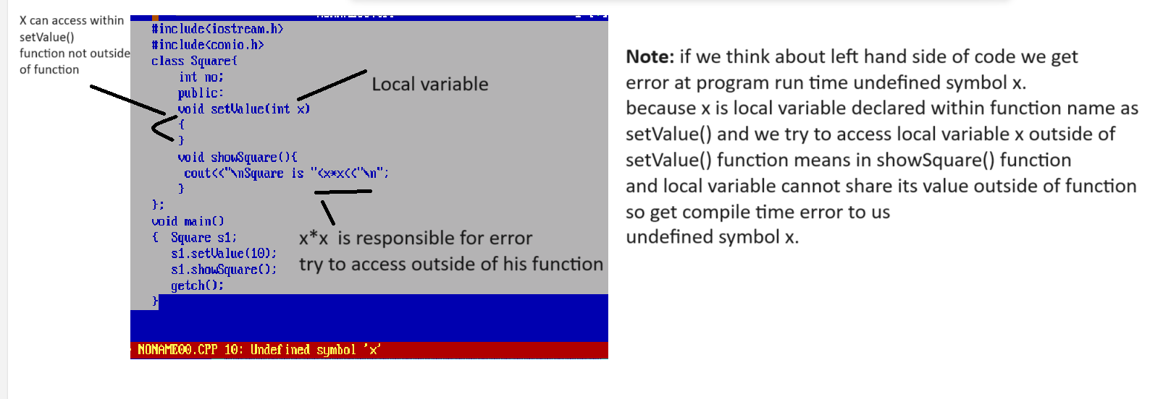
Note: if we want to solve above type of error then we need to copy the value of local variable in instance variable or variable declared within class as per our example we required to copy the value local variable x in to no because no is instance variable and instance variable can access all function of class shown In following diagram.
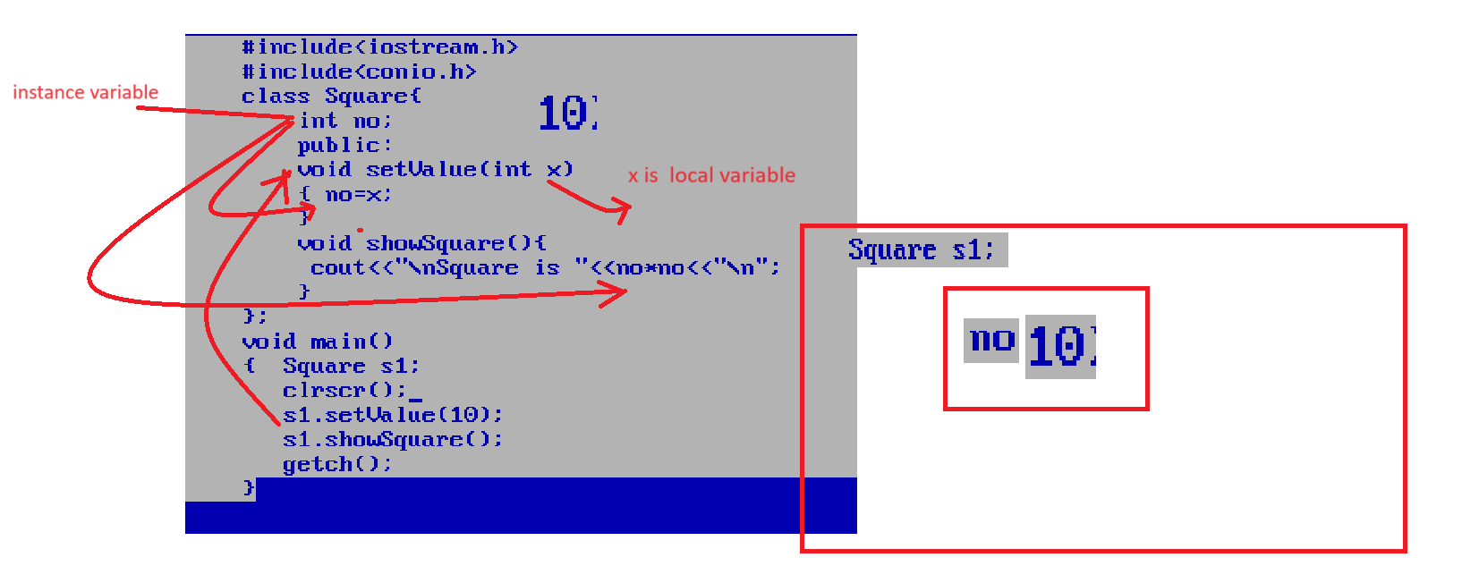
Example: WAP to create class name as Cube with two functions
void setValue(int no): this function can accept no as a parameter
int getCube(): this function can calculate cube of no and return it

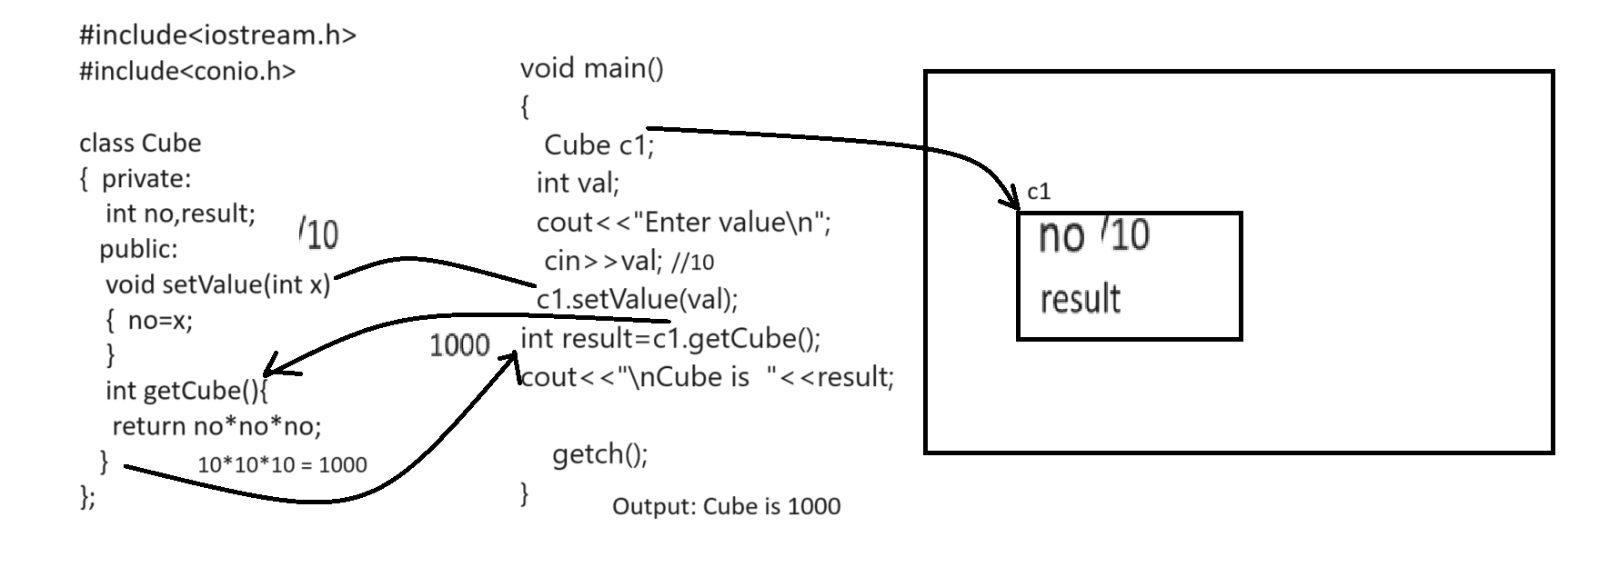
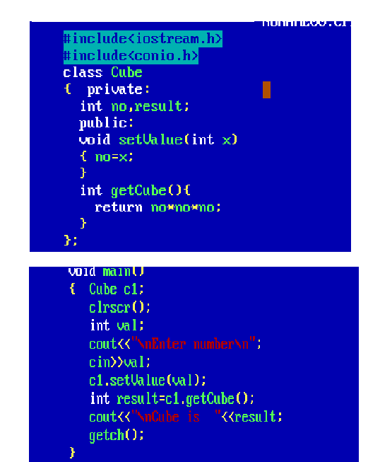

Example: WAP to create class name as Power with two function
void setBaseIndex(int base,int index): this function can accept two values base and index
int getPower(): this function can calculate power of number and return it.
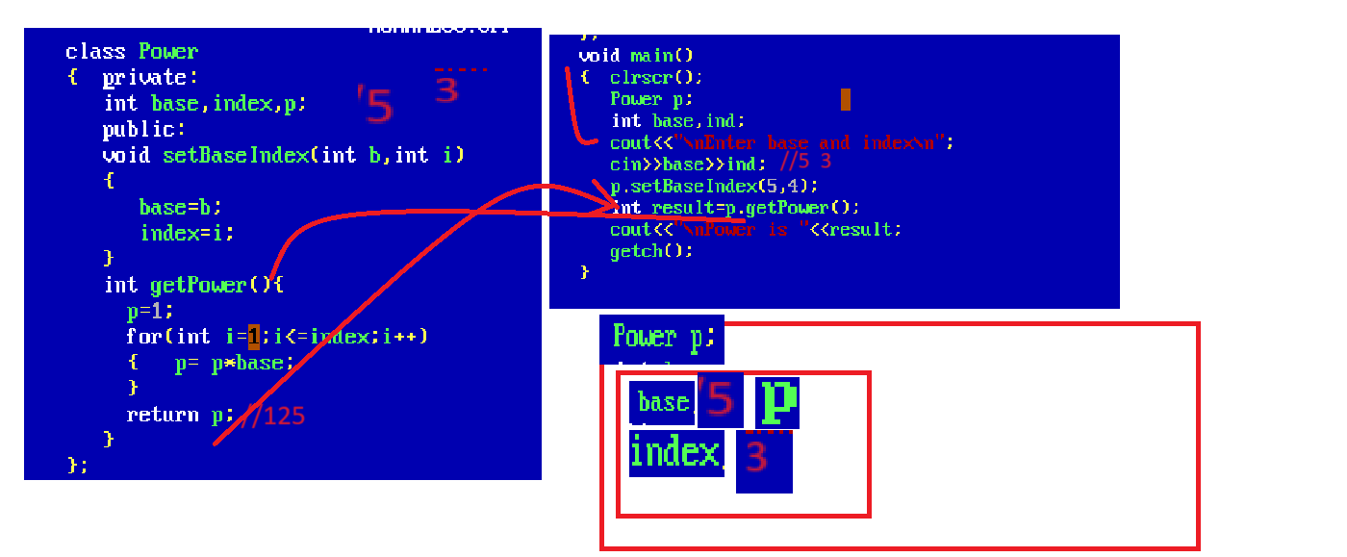

Exmaple: WAP to create class name as Factorial with two functions
void setValue (int no): this function accept integer as parameter
int getFactorial (): this function calculate factorial and return it.

How to pass array as parameter to class function
_____________________________________________________________________________
If we want to pass array as parameter to class function we have to pass base address of array in function and we need to declare on pointer as instance variable for store the base address of array.

Example: Suppose consider we have class name as Sum with functions
void setValue(int a[]): this function is used for accept array as parameter
int getSum(): this function can calculate sum of all values of array and return it.

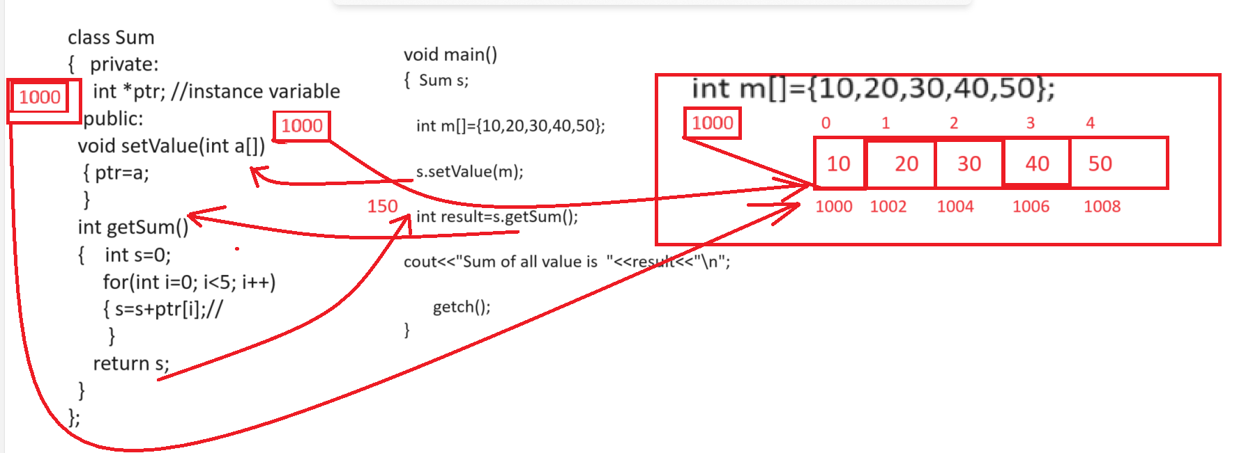

Example: WAP to class name as FindMax with two functions
void setArray(int a[]): this function is used for accept array as parameter
int getMax(): this function is used for find the maximum value from array and return it.

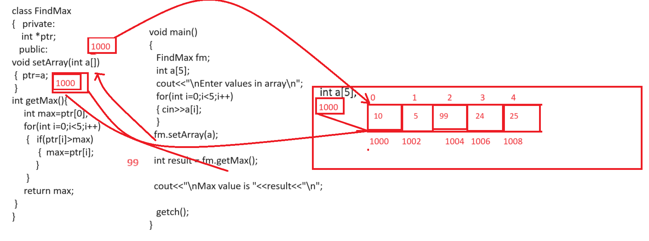

Example: WAP to create class name as ToUpperCase with two functions
void setCharArray(char[]): this function is used for accept array as input
void convertToUpperCase(): this function is used for convert your lower case string to upper case.

Note:if we want to pass string to the function as parameter then we have to ways to use string in class
A. by using strcpy() function
B. by using character pointer.
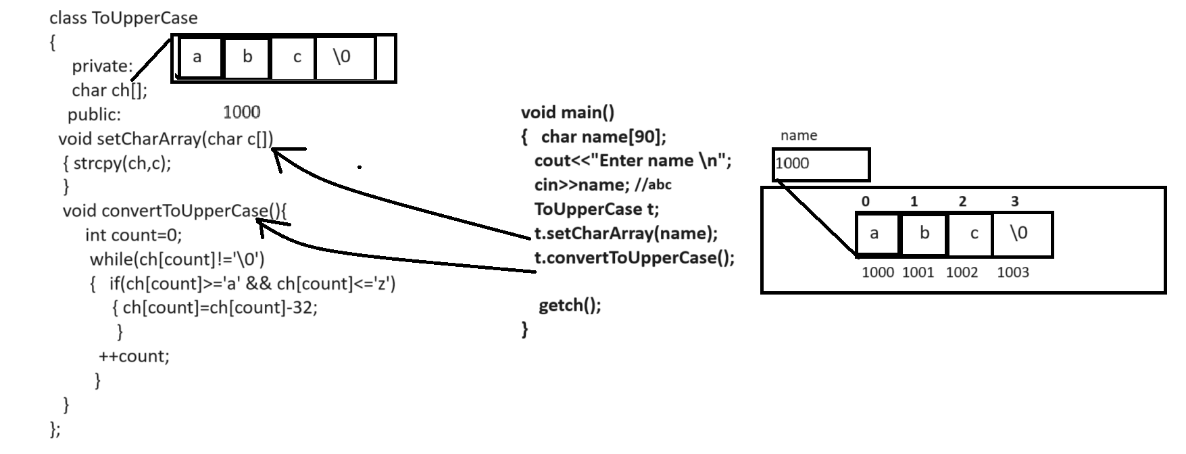

#include<iostream.h>
#include<conio.h>
#include<string.h>

class ToConvertUpper
{
private:
char ch[90];
public:
void setCharArray(char c[])
{ strcpy(ch,c);
}
void convertToUpperCase(){
int count=0;
while(ch[count]!='\0')
{
if(ch[count]>='a' && ch[count]<='z')
{
ch[count]=ch[count]-32;
}
++count;
}
cout<<"\nAfter conversion "<<ch;
}
};

void main(){
char name[90];
ToConvertUpper c;
cout<<"\nEnter name from string\n";
cin>>name;
c.setCharArray(name);
c.convertToUpperCase();
getch();
}

Example: WAP to create class name as FindLength with functions
void setCharArray(char[]): this function accept character array as input
int getLength(): this function can calculate length of string and return it.

Array of object
_________________________________________________________________________
Array of object is used for to store more than one object data in single name object called as array of object.
Example: Suppose consider we have class name as Employee with field id,name and salary and we want to create 5 employee object and display its data.
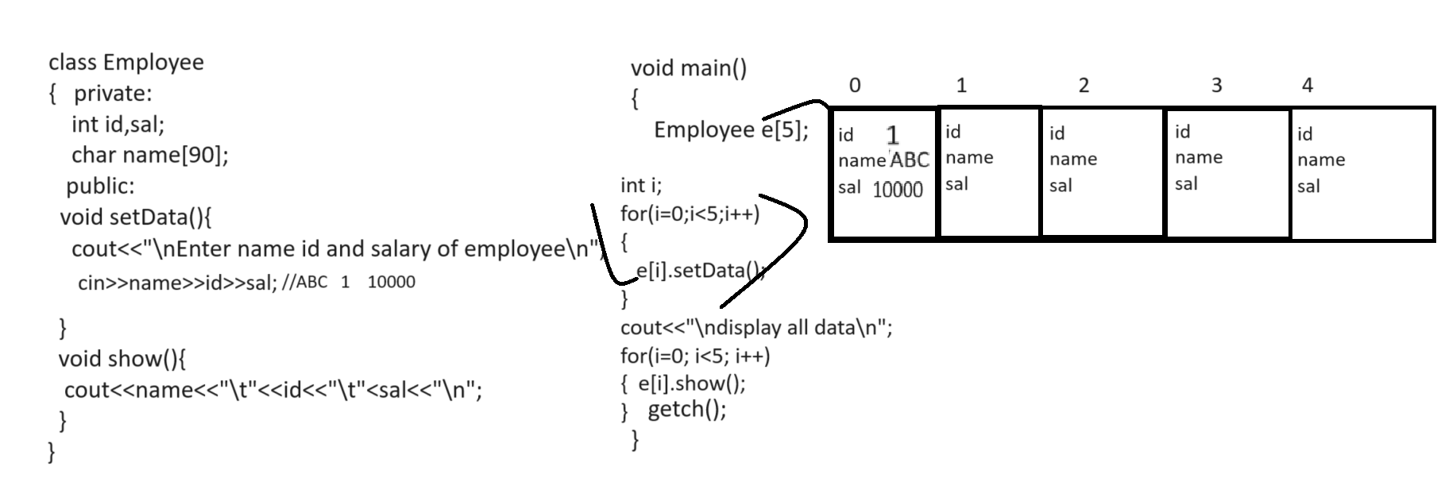

#include<iostream.h>
#include<conio.h>
#include<string.h>
class Employee
{
private:
int id,sal;
char name[90];
public:
void setData(){
cout<<"\nEnter name id and salary of employee\n";
cin>>name>>id>>sal;
}
void showData(){
cout<<name<<"\t"<<id<<"\t"<<sal<<"\n";
}
};
void main(){
Employee e[5];
clrscr();
for(int i=0;i<5;i++)
{ e[i].setData();
}
cout<<"\ndisplay all employee data\n";
for(i=0;i<5;i++)
{ e[i].showData();
}
getch();
}
If we use the array of object concept then we cannot allocate memory of object at run or cannot allocate dynamic memory of object so if we want to allocate memory dynamically we can use pointer with object.

Pointer of object
__________________________________________________________________________
Pointer of object help us to allocate memory of object at run time or allocate dynamic memory of object so when we use the pointer of object then we can use - >(arrow) operator for access class member
#include<iostream.h>
#include<conio.h>
#include<string.h>
class Employee
{ private:
int id,sal;
char name[90];
public:
void setData(){
cout<<"\nEnter name id and salary of employee\n";
cin>>name>>id>>sal;
}
void showData(){
cout<<name<<"\t"<<id<<"\t"<<sal<<"\n";
}
};
void main(){
clrscr();
Employee *e;
e->setData();
e->showData();
getch();
}

How to allocate dynamic memory of object at run by using pointer
____________________________________________________________________________
1. By using malloc () function: malloc function helps us to create run time array or dynamic array.
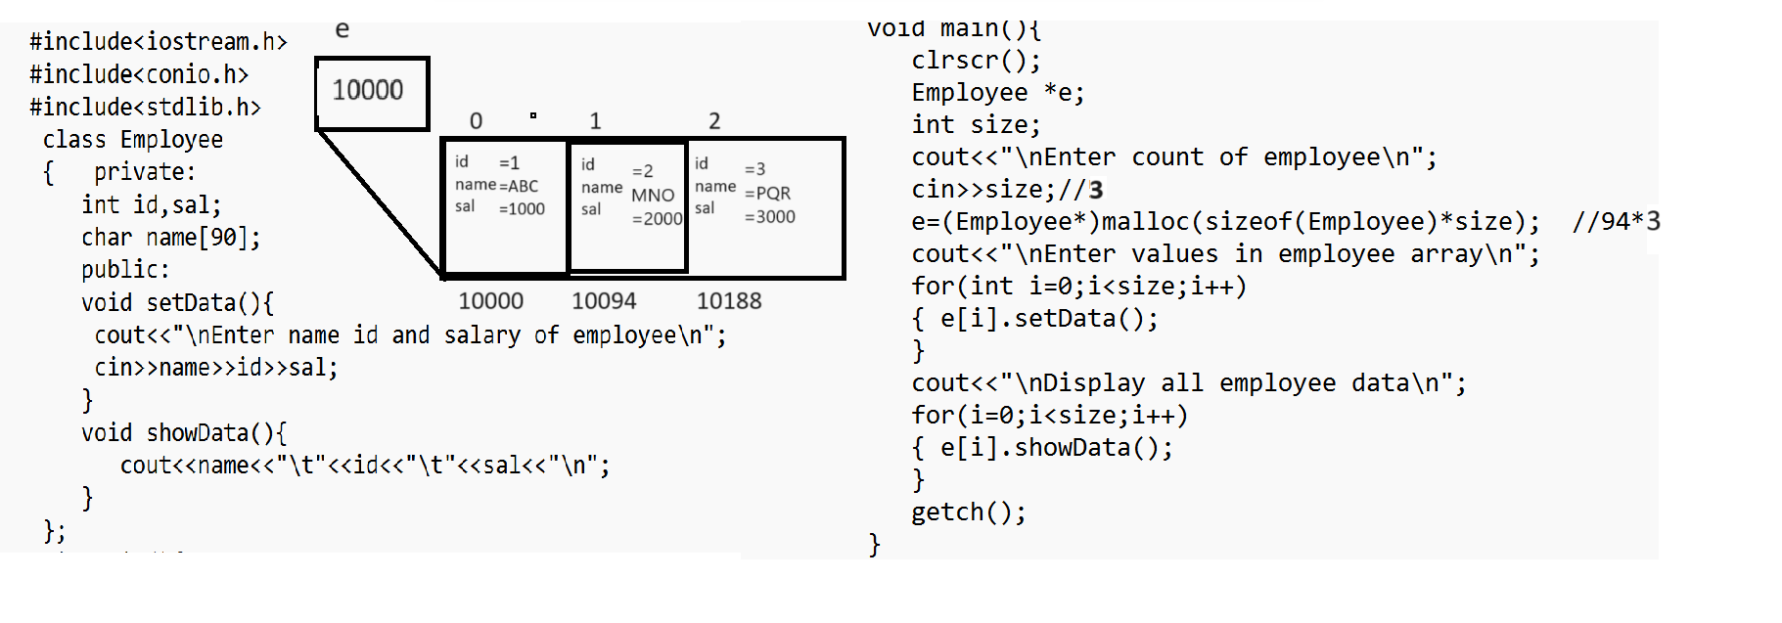

Q1. WAP to create class name as Sort with two methods
void acceptArray(int a[]): this function can accept array as parameter
void sort(): this function can sort the array in ascending order.

Q2. WAP to create class name as Reverse with two methods/function
void acceptArray(int a[]): this function can accept array as parameter
void reverse(): this function reverse the array and display it.

Q3. WAP to create class name as CompareString with function
void setString(char[],char[]): this function can accept two strings as parameter
int compareString(): this function compare two strings with each other and if strings equal return 0
otherwise return -1;
Note: do not use any inbuilt function for string comparision.

Q4. WAP to create class name as ExtractDigitFromString two methods
void setString(char[]): this function can accept string as parameter
void extractDigit(): this function can extract digit from string and display it.

2. By using new keyword in C++

3. Provide encapsulation.

